**DATA STORYTELLING FOR Q4 2022**

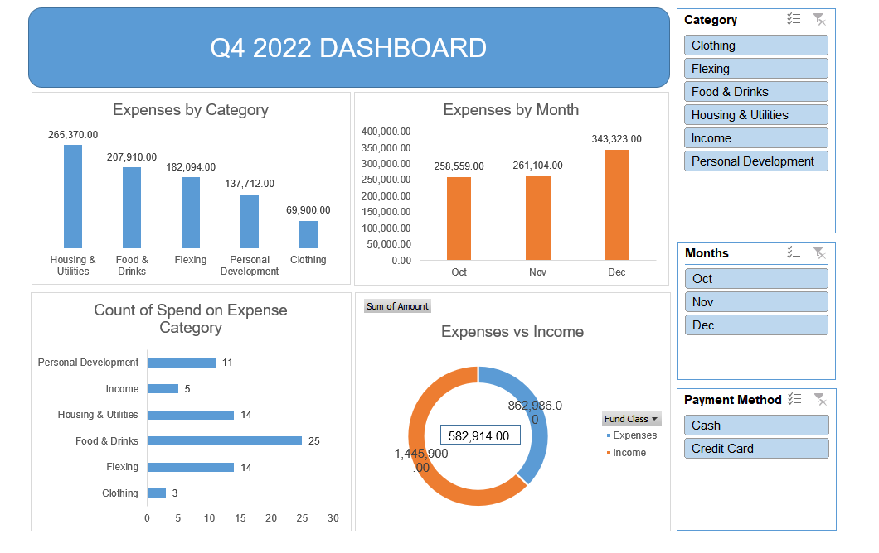

**PROBLEM STATEMENT**

The goal and objective of this project is to visualize and analyze the income and expenses for Q4 2022. It aims to identify spending patterns, how expenses are distributed across categories and months, and make informed financial decisions.

**DATA EXPLORATION AND ANALYSIS**

* **Expenses by Category**: Housing & Utilities is the highest expense, followed by Food & Drinks and Flexing. Clothing has the lowest expense.
* **Expenses by Month**: There is a steady increase in expenses from October to December, with December being the highest.
* **Count of Spend on Expense Category**: Food & Drinks has the highest frequency of transactions, while Income and Clothing have the lowest.
* **Expenses vs Income**: The total expenses are $1,445,900, while the income is $862,986, indicating a significant deficit.

**KEY INSIGHTS AND RECCOMENDATRIONS**

* **High Spending on Housing & Utilities and Food & Drinks**: Focus on reducing costs in these categories.
* **Seasonal Increase in December**: Implement budgeting strategies for holiday-related expenses.
* **Income vs Expense Gap**: Explore additional income sources or cut down on unnecessary spending.
* **Payment Method Analysis**: Assess the impact of cash vs credit card spending to manage debt effectively.

**VISUALIZATION AND DASHBOARD FEATURES**

* **Bar and Pie Charts**: Effectively showcase spending patterns and comparisons.
* **Filters for Category, Month, and Payment Method**: Allow granular analysis for better decision-making.
* **Interactive Dashboard**: Enables users to drill down into specific areas of interest.

CONCLUSION

The dashboard provides a comprehensive overview of expenses and income for Q4 2022. By identifying high-cost categories and understanding spending trends, users can make informed financial decisions to manage expenses and bridge the income-expense gap.